MANY TO MANY RELATIONSHIP

EXAMPLES

Books <-> Authors
explain:books can have multiple authors. Authors can have multiple books

Blog Post <-> Tags
Instagram Post or Tumblr Post. Tags represent Pictures.

Students <-> Classes
Students have multiple classes.

Series Data

|
Reviews Data -> TABLES
|

Reviewers Data

Reviewers Series Reviews

Id id id
First_name title rating
Last_name released_year series_id
Genre reviewer_id

Reviewer_id is foreign key connected to the reviewers table “id” and Series_id is a foreign key connected to the Series table “id”.

1.Reviewers Table

Id first_name last_name
1 Blue Steele
2 Wyatt Earp

2.Series Table

Id title released_year genre
1 Archer 2009 Animation
2 Fargo 2014 Drame

3.Reviews Table

Id rating reviewer_id series_id
1 8.9 1 2
2 9.5 2 2

CREATING TABLES

Code

- CREATE TABLE reviewers (
- id INT PRIMARY KEY AUTO_INCREMENT,
- first_name VARCHAR(50) NOT NULL,
- last_name VARCHAR(50) NOT NULL
- );

- CREATE TABLE series (
- id INT PRIMARY KEY AUTO_INCREMENT,
- title VARCHAR(100),
- released_year YEAR,
- genre VARCHAR(100)
- );

- CREATE TABLE reviews (
- id INT PRIMARY KEY AUTO_INCREMENT,
- rating DECIMAL(2 , 1 ),
- series_id INT,
- reviewer_id INT,
- FOREIGN KEY (series_id)
- REFERENCES series (id),
- FOREIGN KEY (reviewer_id)
- REFERENCES reviewers (id)
- );

- INSERT INTO series (title, released_year, genre) VALUES
- ('Archer', 2009, 'Animation'),
- ('Arrested Development', 2003, 'Comedy'),
- ("Bob's Burgers", 2011, 'Animation'),
- ('Bojack Horseman', 2014, 'Animation'),
- ("Breaking Bad", 2008, 'Drama'),
- ('Curb Your Enthusiasm', 2000, 'Comedy'),
- ("Fargo", 2014, 'Drama'),
- ('Freaks and Geeks', 1999, 'Comedy'),
- ('General Hospital', 1963, 'Drama'),
- ('Halt and Catch Fire', 2014, 'Drama'),
- ('Malcolm In The Middle', 2000, 'Comedy'),
- ('Pushing Daisies', 2007, 'Comedy'),
- ('Seinfeld', 1989, 'Comedy'),
- ('Stranger Things', 2016, 'Drama');

- INSERT INTO reviewers (first_name, last_name) VALUES
- ('Thomas', 'Stoneman'),
- ('Wyatt', 'Skaggs'),
- ('Kimbra', 'Masters'),
- ('Domingo', 'Cortes'),
- ('Colt', 'Steele'),
- ('Pinkie', 'Petit'),
- ('Marlon', 'Crafford');

- INSERT INTO reviews(series_id, reviewer_id, rating) VALUES
- (1,1,8.0),(1,2,7.5),(1,3,8.5),(1,4,7.7),(1,5,8.9),
- (2,1,8.1),(2,4,6.0),(2,3,8.0),(2,6,8.4),(2,5,9.9),
- (3,1,7.0),(3,6,7.5),(3,4,8.0),(3,3,7.1),(3,5,8.0),
- (4,1,7.5),(4,3,7.8),(4,4,8.3),(4,2,7.6),(4,5,8.5),
- (5,1,9.5),(5,3,9.0),(5,4,9.1),(5,2,9.3),(5,5,9.9),
- (6,2,6.5),(6,3,7.8),(6,4,8.8),(6,2,8.4),(6,5,9.1),
- (7,2,9.1),(7,5,9.7),
- (8,4,8.5),(8,2,7.8),(8,6,8.8),(8,5,9.3),
- (9,2,5.5),(9,3,6.8),(9,4,5.8),(9,6,4.3),(9,5,4.5),
- (10,5,9.9),
- (13,3,8.0),(13,4,7.2),
- (14,2,8.5),(14,3,8.9),(14,4,8.9);



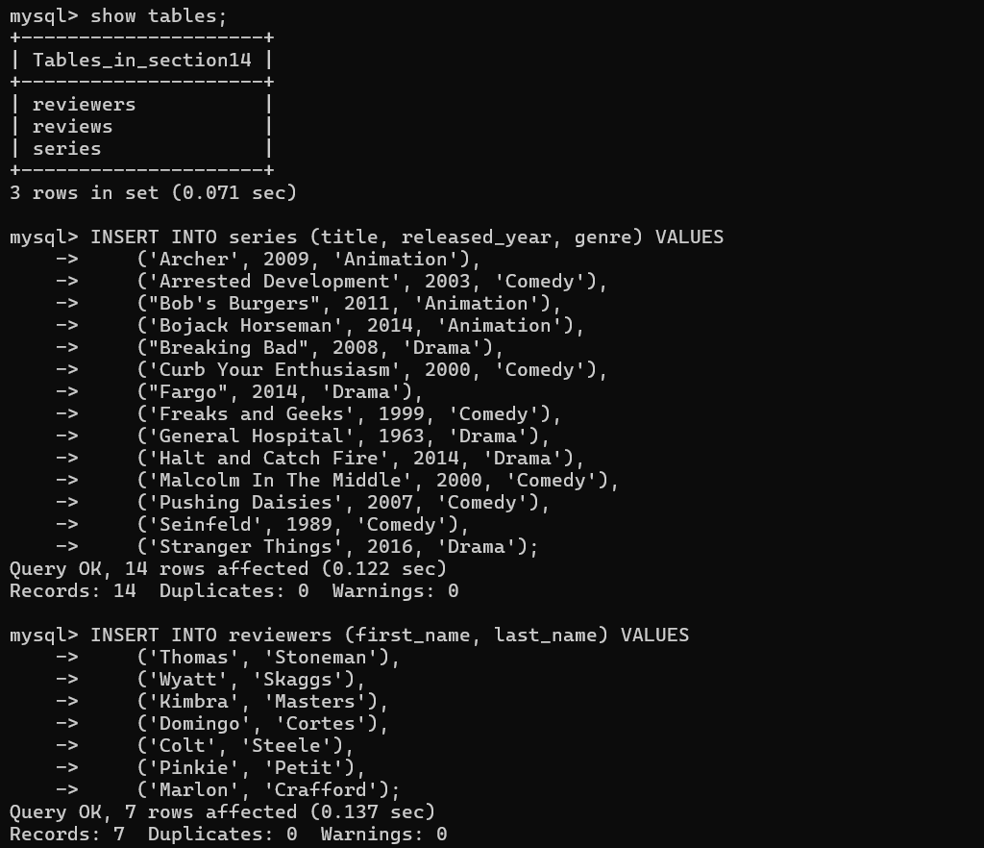

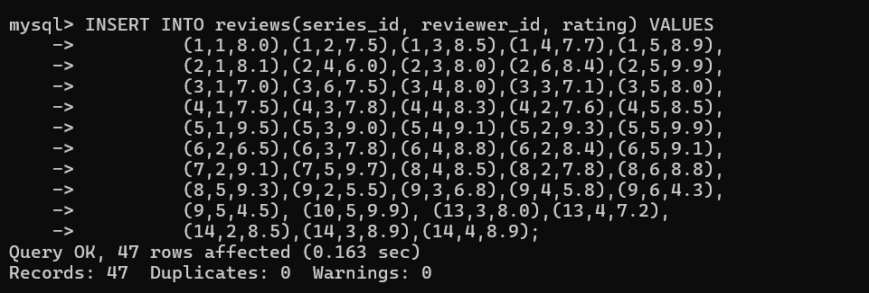

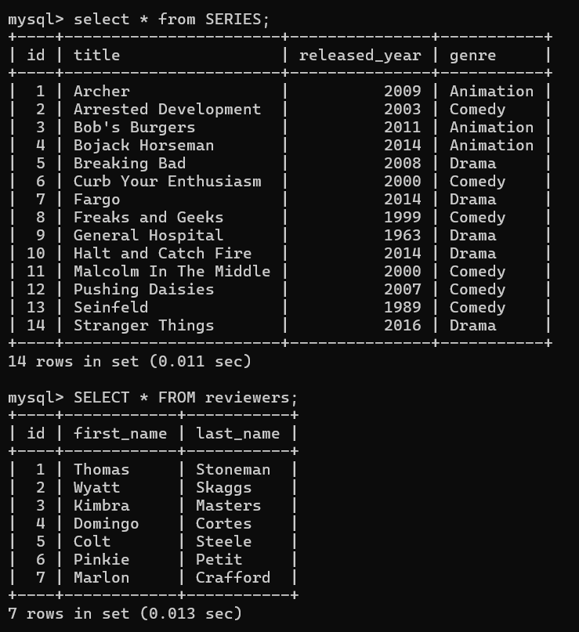

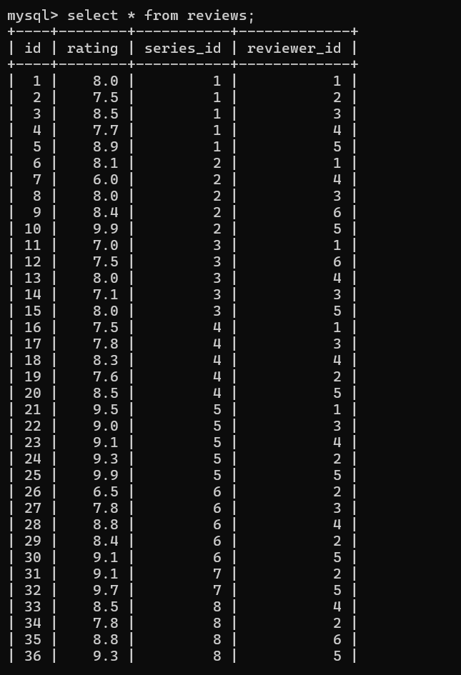
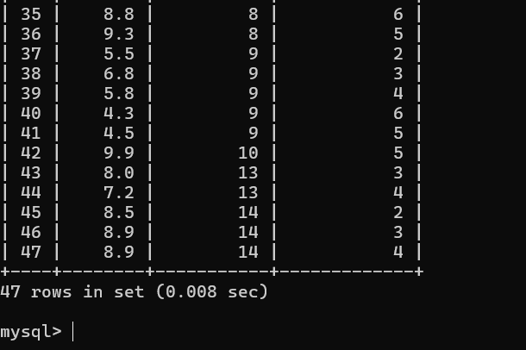

TV Series challenge 1

CODE:

- SELECT title, rating
- FROM series JOIN
- reviews ON series.id = reviews.series_id;

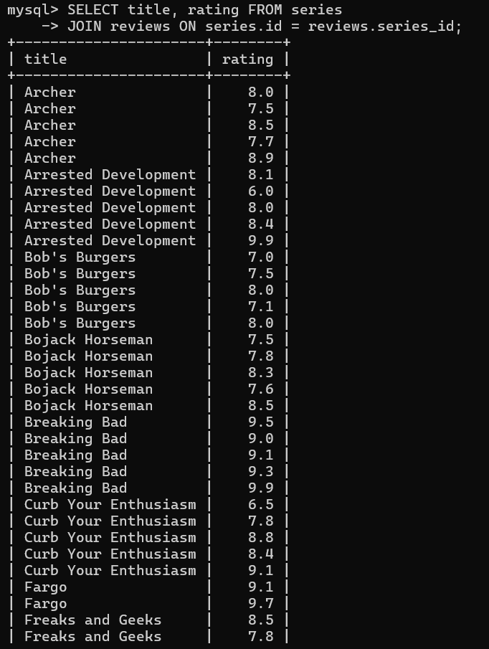

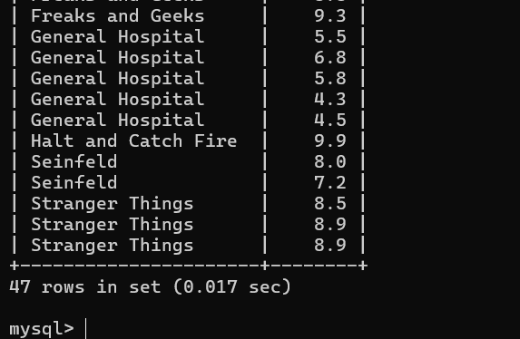

TV Series challenge 2

CODE:

- SELECT
- title, ROUND(AVG(rating), 2) AS avg_rating
- FROM
- series
- JOIN
- reviews ON series.id = reviews.series_id
- GROUP BY title
- ORDER BY avg_rating;

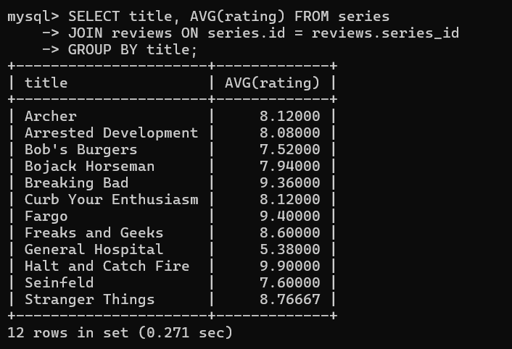

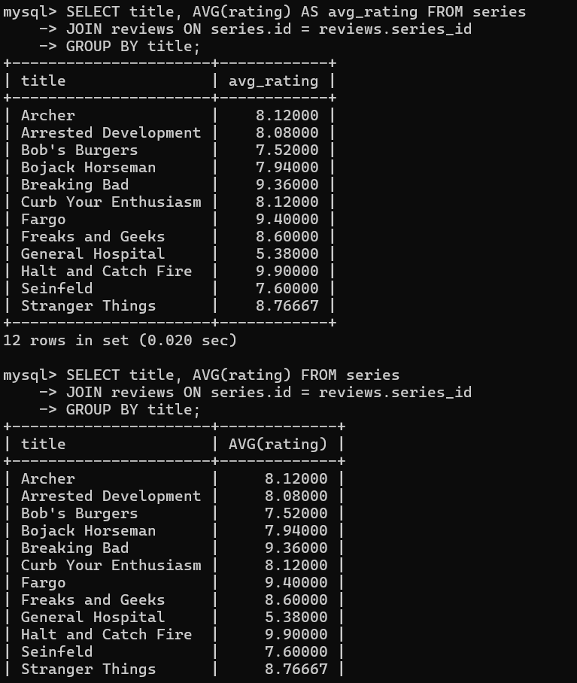

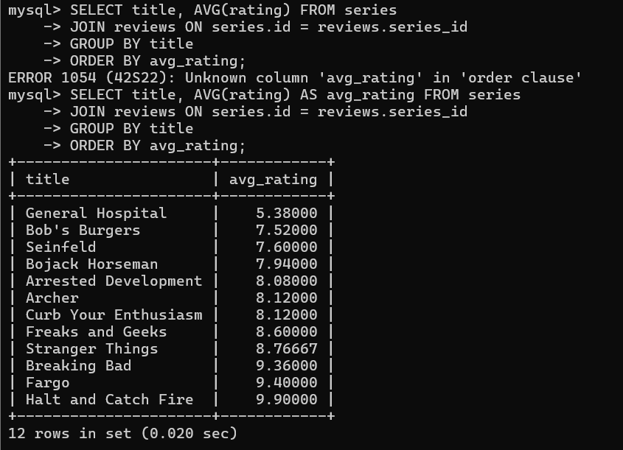
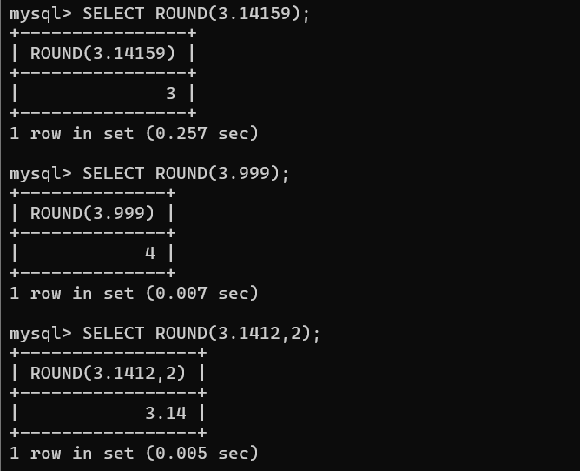

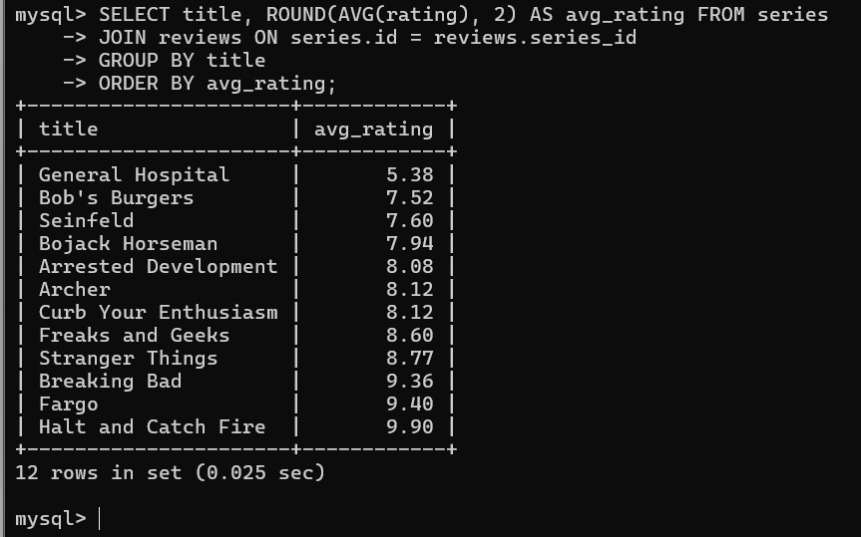

TV Series challenge 3

CODE:

- SELECT
- first_name, last_name, rating
- FROM
- reviewers
- JOIN
- reviews ON reviews.reviewer_id = reviewers.id;

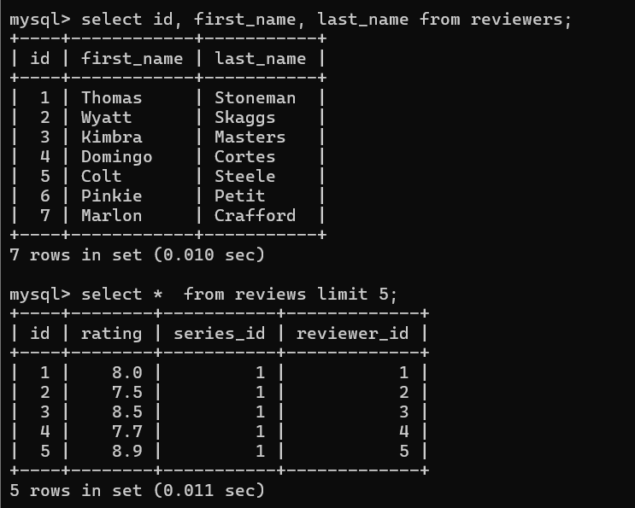

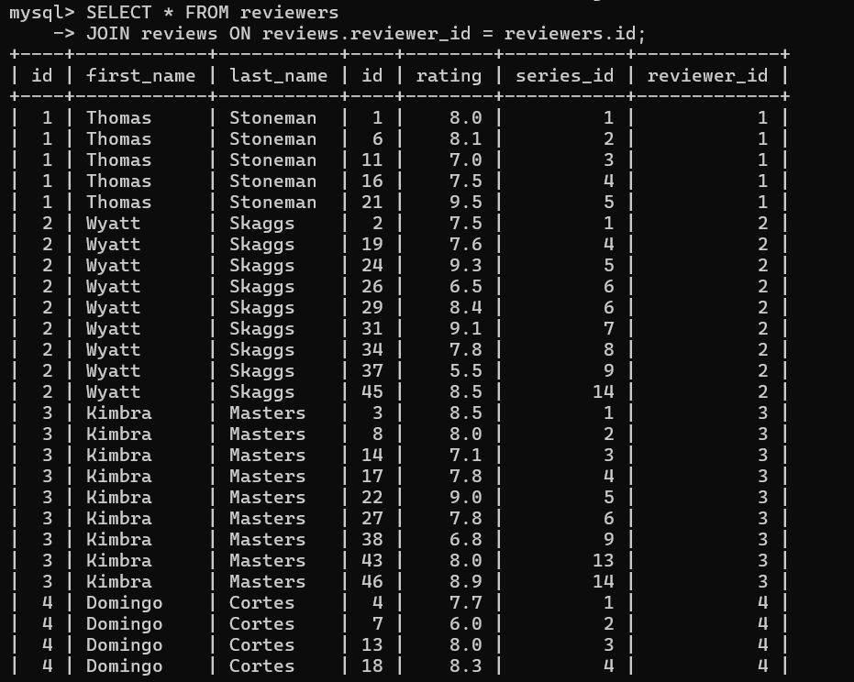

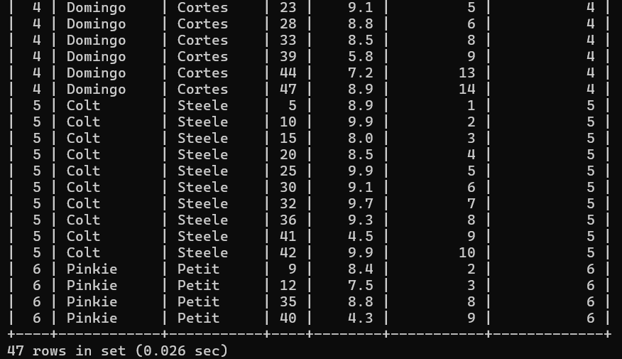

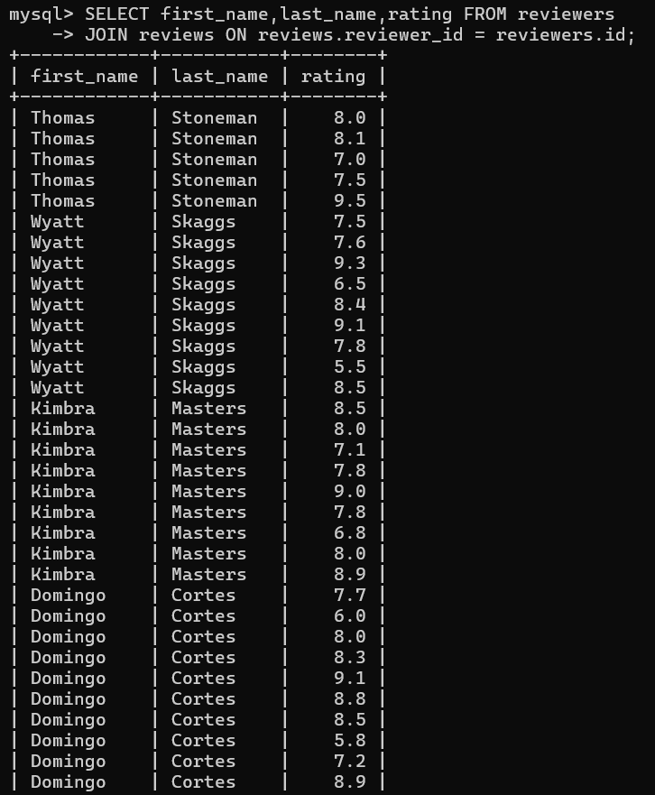

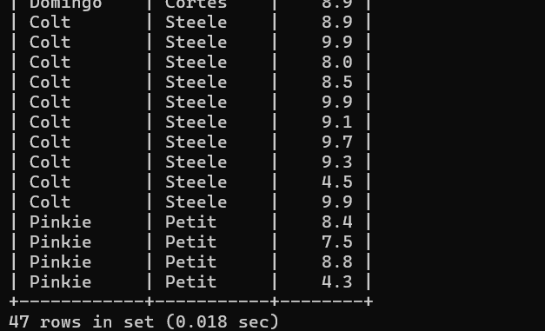

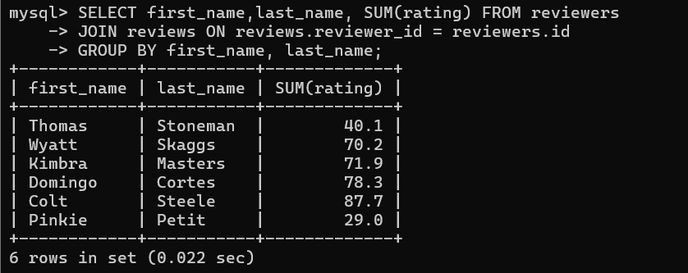

TV Series challenge 4

Code

- SELECT
- title AS unreviewed_series
- FROM
- series
- LEFT JOIN
- reviews ON series.id = reviews.series_id
- WHERE
- rating IS NULL;

- SELECT
- title AS unreviewed_series
- FROM
- reviews
- RIGHT JOIN
- series ON series.id = reviews.series_id
- WHERE
- rating IS NULL;

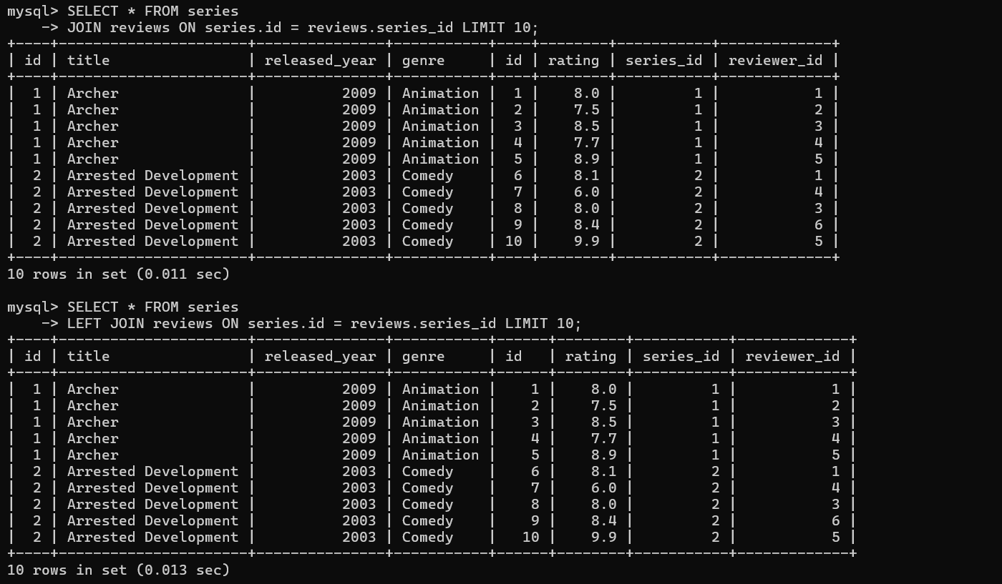

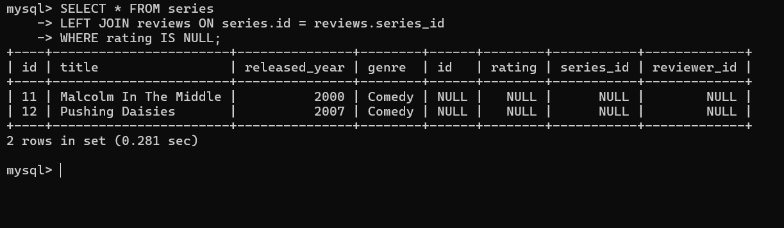

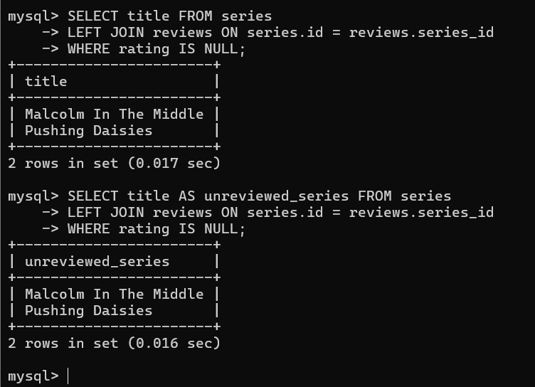

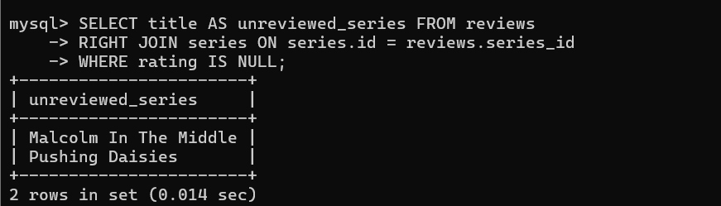

TV Series challenge 5

CODE

- SELECT
- genre, ROUND(AVG(rating), 2) AS avg_rating
- FROM
- series
- JOIN
- reviews ON series.id = reviews.series_id
- GROUP BY genre;

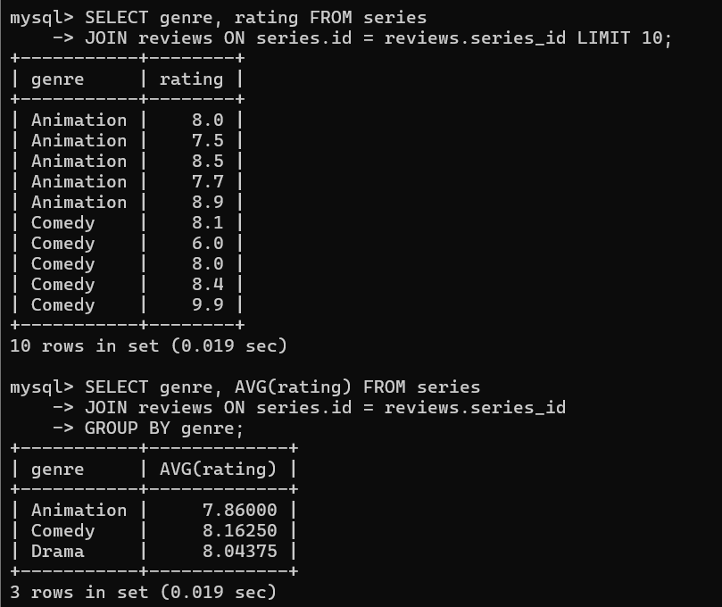

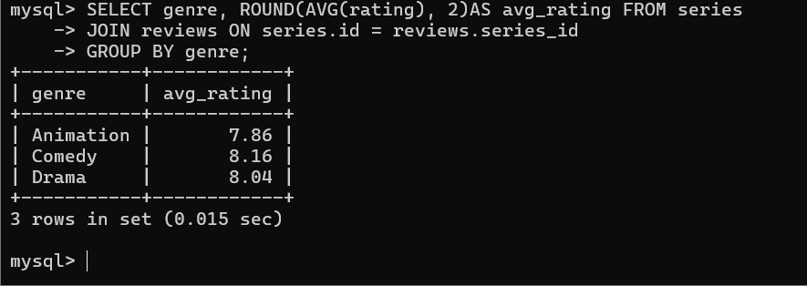

TV Series challenge 6

CODE:

- -- USING CASE
- SELECT
- first_name,
- last_name,
- COUNT(rating) AS count,
- IFNULL(MIN(rating), 0) AS min,
- IFNULL(MAX(rating), 0) AS max,
- ROUND(IFNULL(AVG(rating), 0), 2) AS average,
- CASE
- WHEN COUNT(rating) >= 10 THEN 'POWERUSER'
- WHEN COUNT(rating) > 0 THEN 'ACTIVE'
- ELSE 'INACTIVE'
- END AS status
- FROM
- reviewers
- LEFT JOIN
- reviews ON reviewers.id = reviews.reviewer_id
- GROUP BY first_name , last_name;

- -- USING IF
- SELECT
- first_name,
- last_name,
- COUNT(rating) AS count,
- IFNULL(MIN(rating), 0) AS min,
- IFNULL(MAX(rating), 0) AS max,
- ROUND(IFNULL(AVG(rating), 0), 2) AS average,
- IF(COUNT(rating) > 0,
- 'ACTIVE',
- 'INACTIVE') AS status
- FROM
- reviewers
- LEFT JOIN
- reviews ON reviewers.id = reviews.reviewer_id
- GROUP BY first_name , last_name;

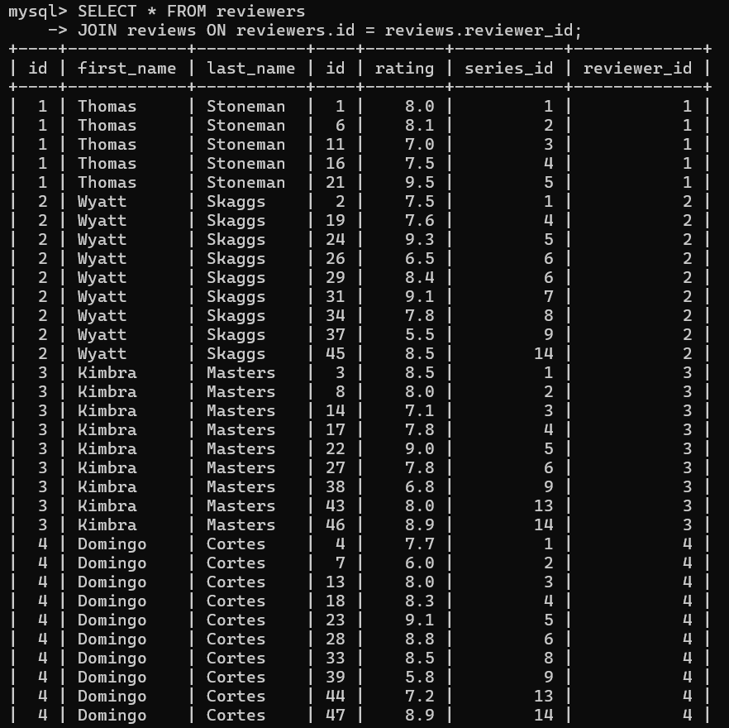

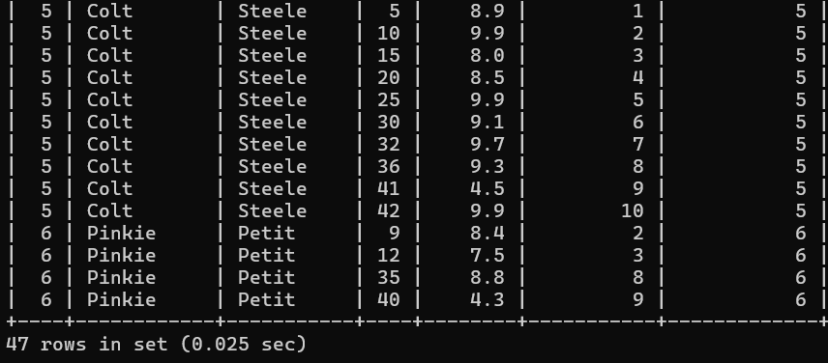

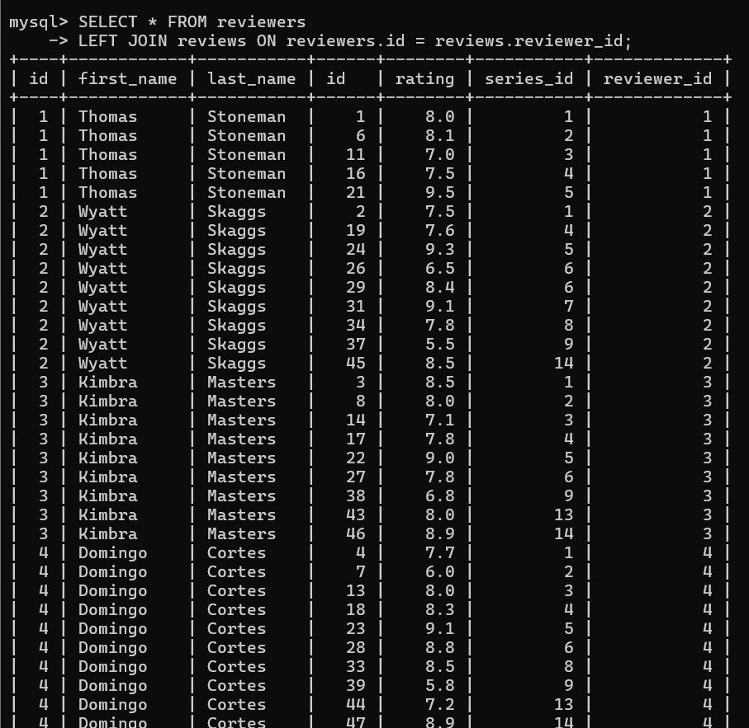

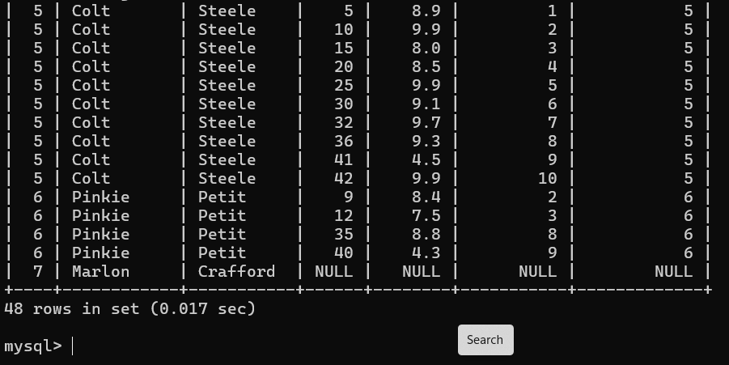

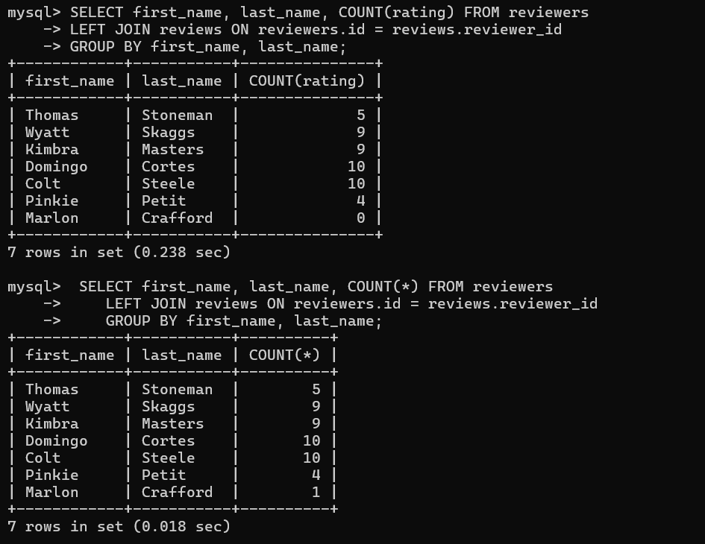
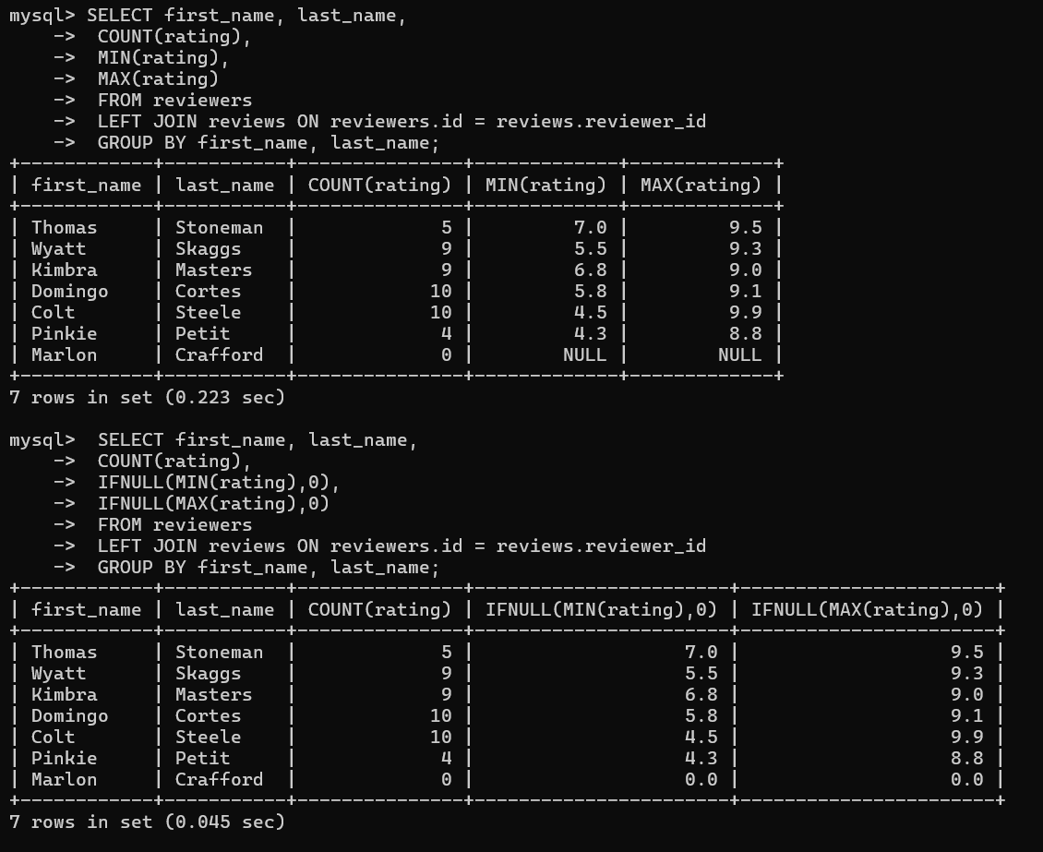

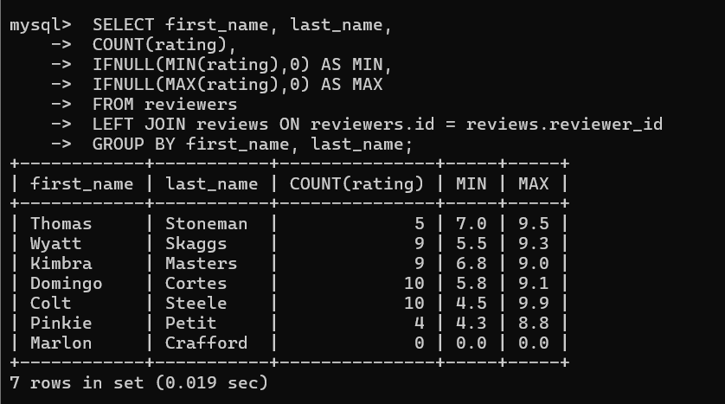

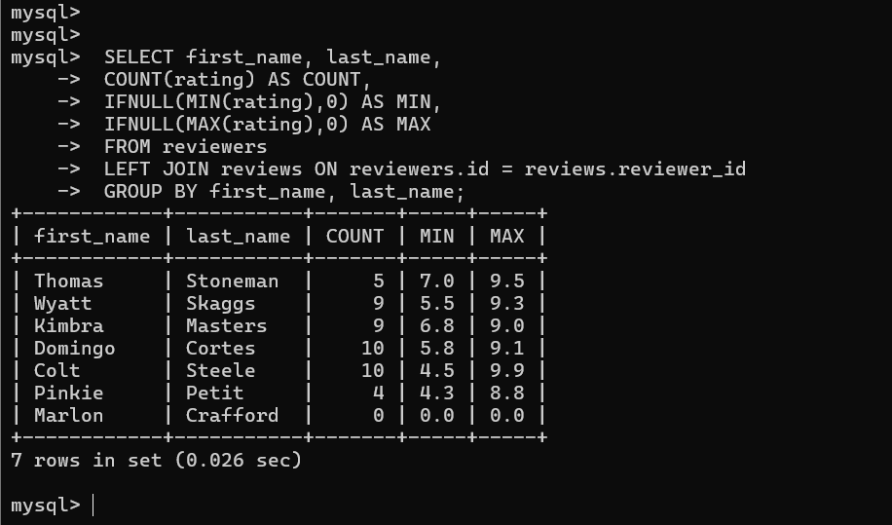

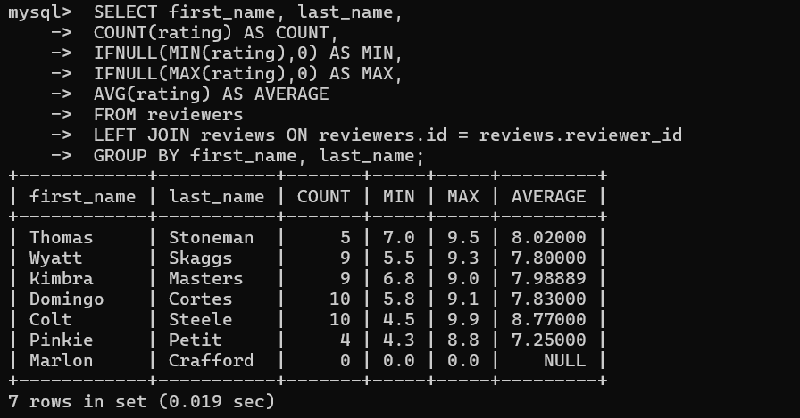

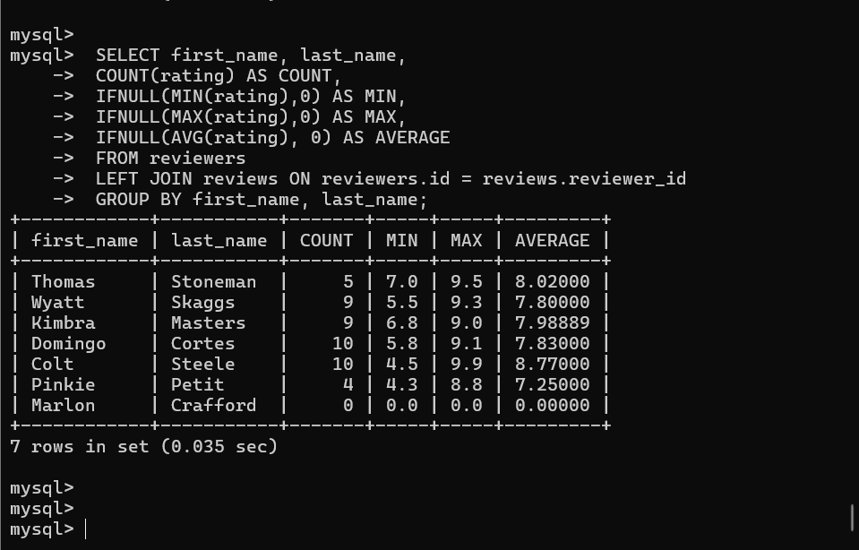

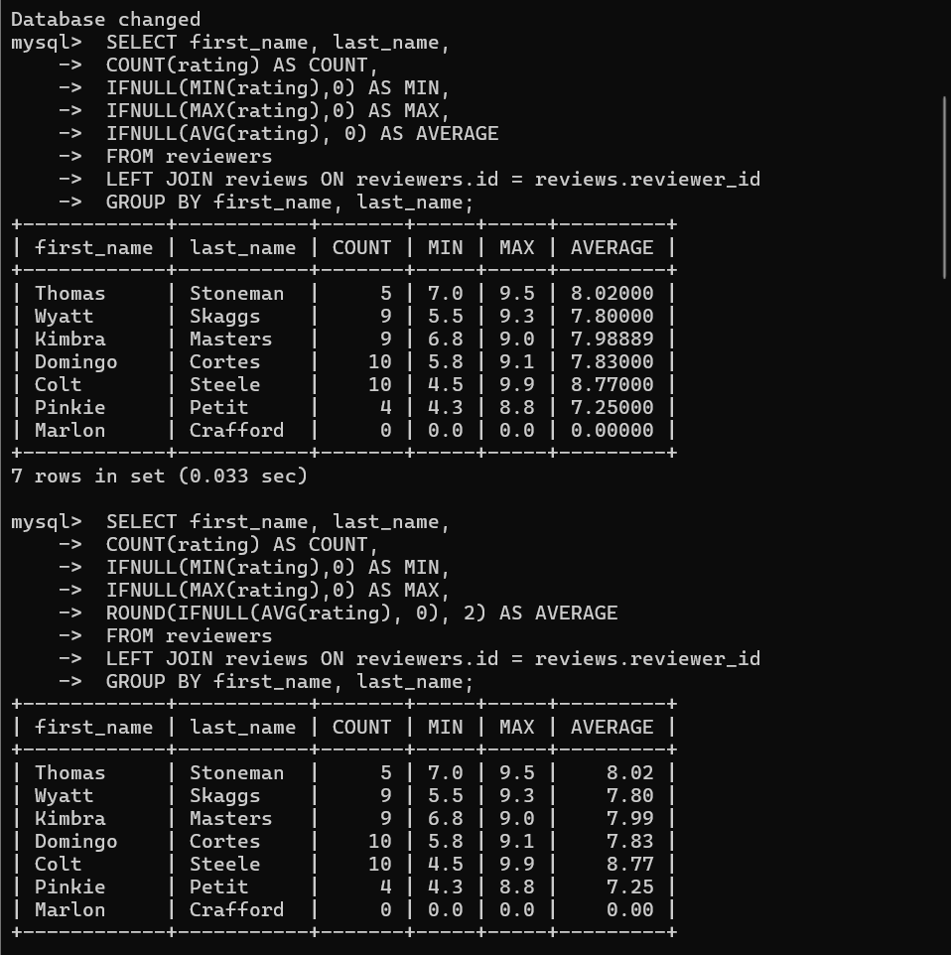

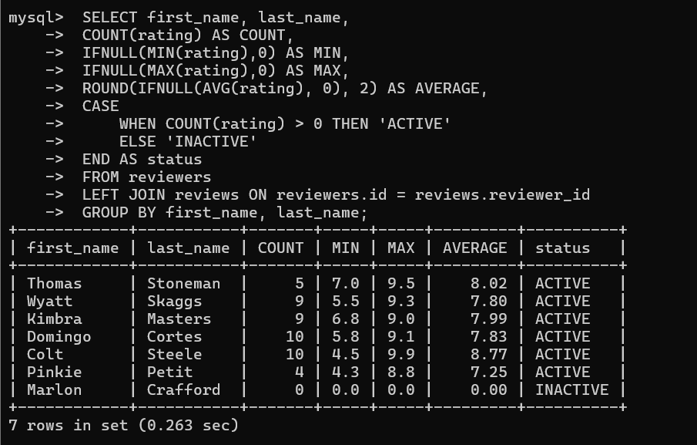

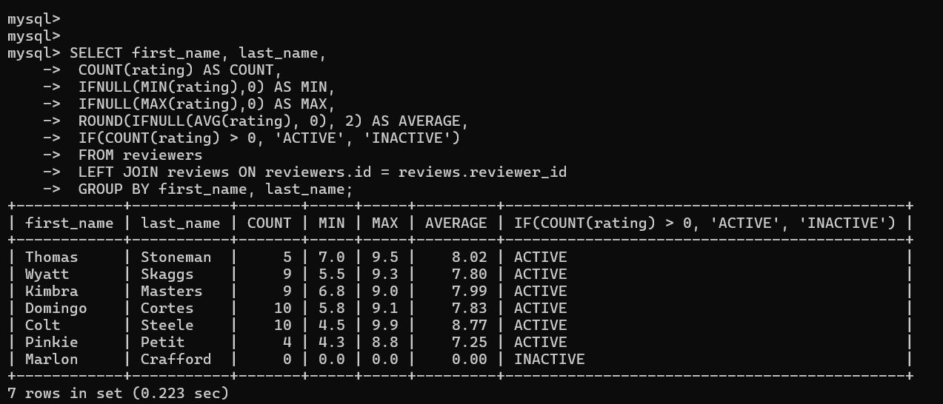

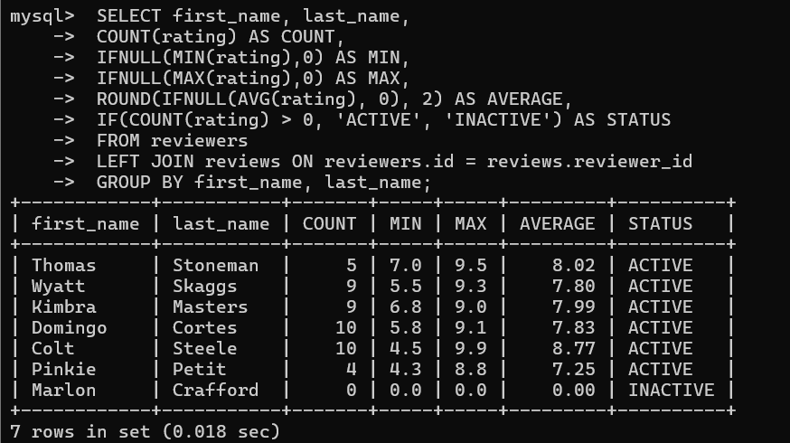

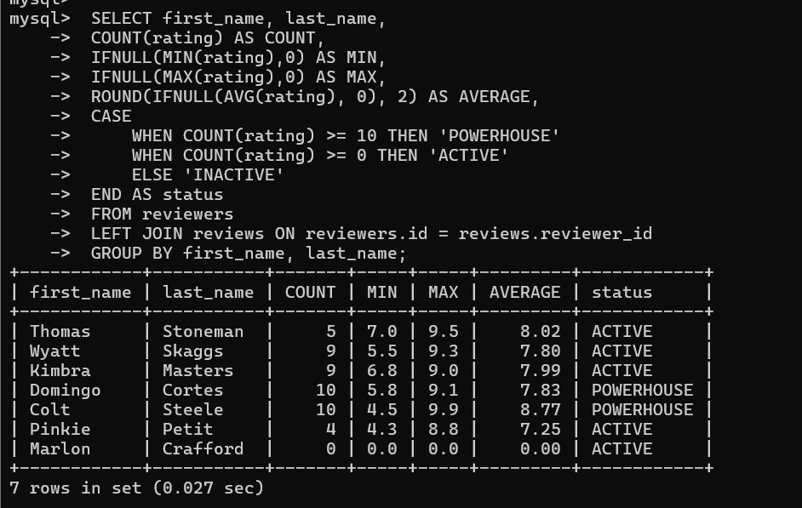

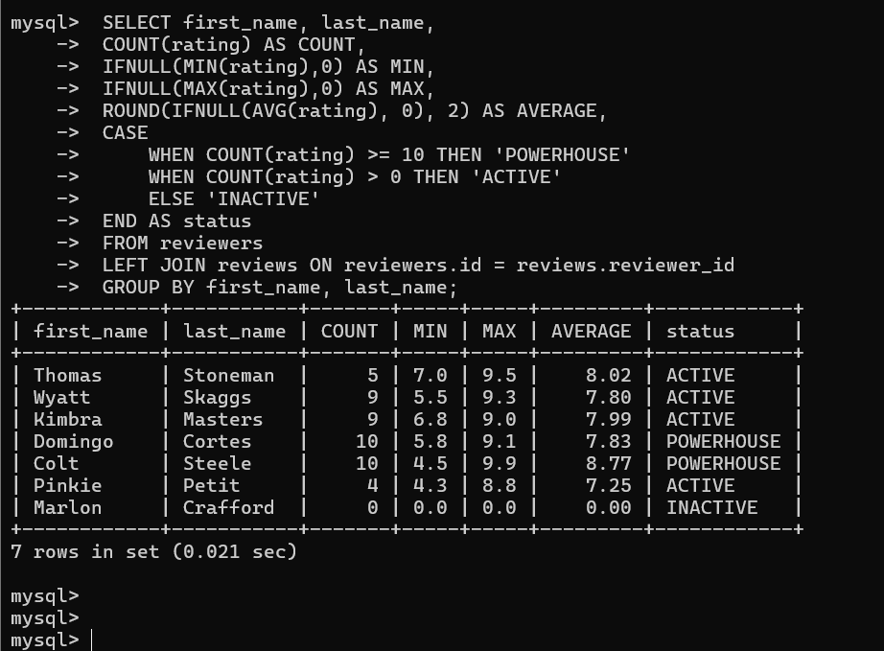

TV Series challenge 7

CODE

- SELECT
- title,
- rating,
- CONCAT(first_name, ' ', last_name) AS reviewer
- FROM
- reviews
- INNER JOIN
- series ON reviews.series_id = series.id
- INNER JOIN
- reviewers ON reviews.reviewer_id = reviewers.id;

- SELECT
- title,
- rating,
- CONCAT(first_name, ' ', last_name) AS reviewer
- FROM
- series
- INNER JOIN
- reviews ON reviews.series_id = series.id
- INNER JOIN
- reviewers ON reviews.reviewer_id = reviewers.id;

- SELECT
- title,
- rating,
- CONCAT(first_name, ' ', last_name) AS reviewer
- FROM
- reviewers
- INNER JOIN
- reviews ON reviews.reviewer_id = reviewers.id
- INNER JOIN
- series ON reviews.series_id = series.id;
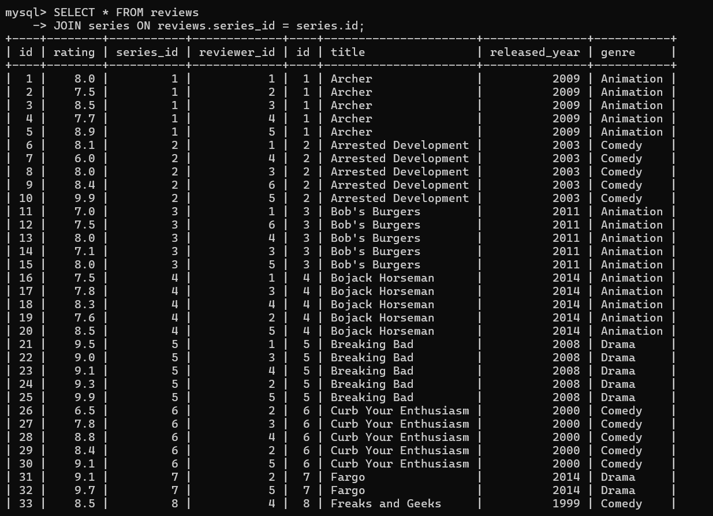

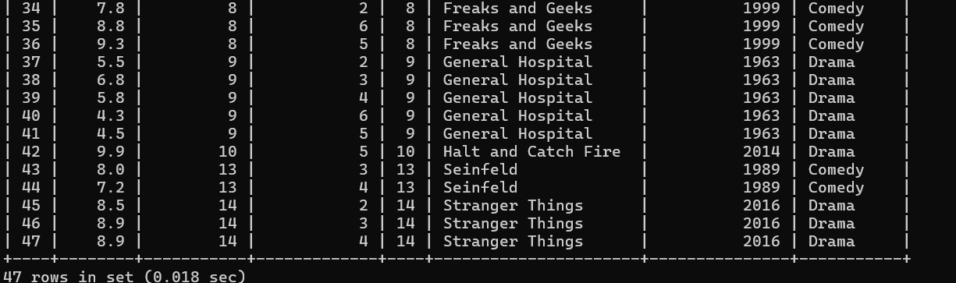

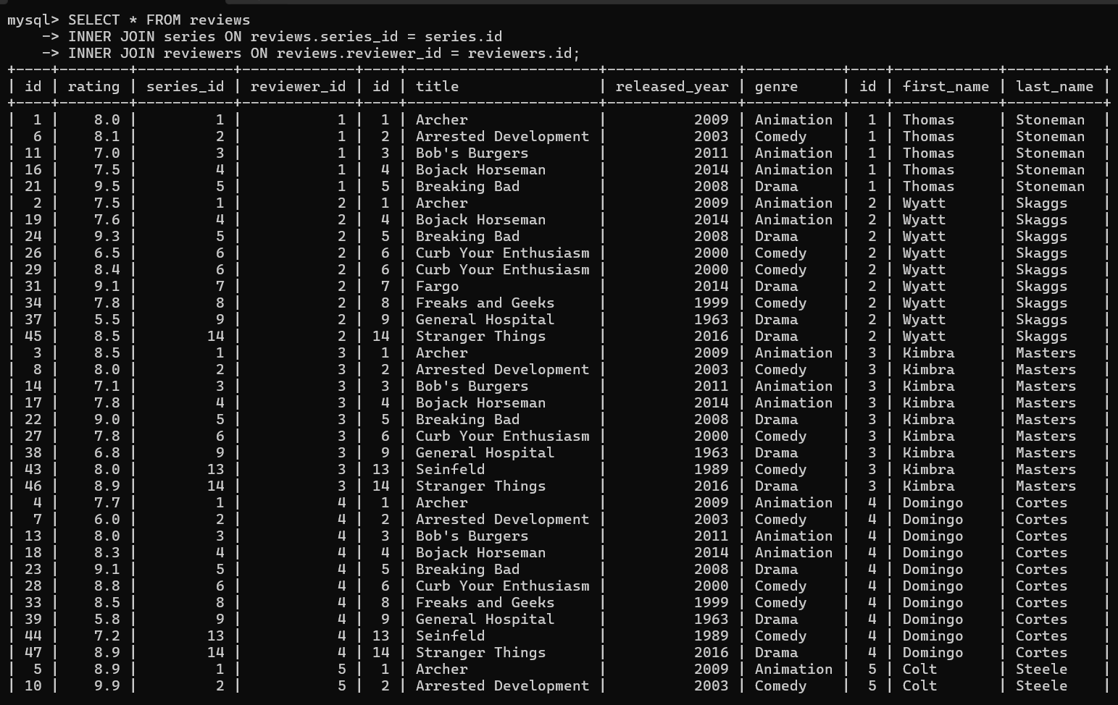

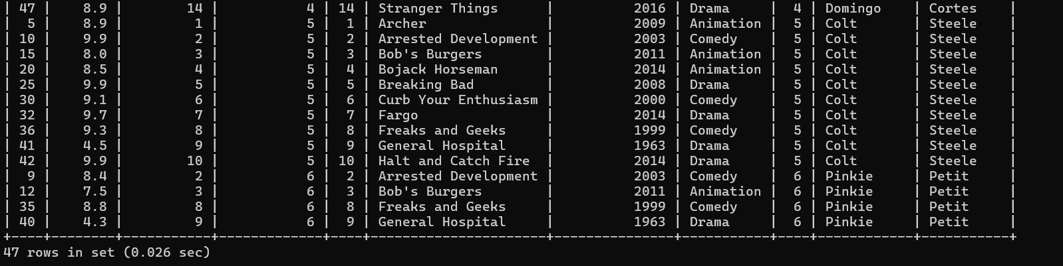

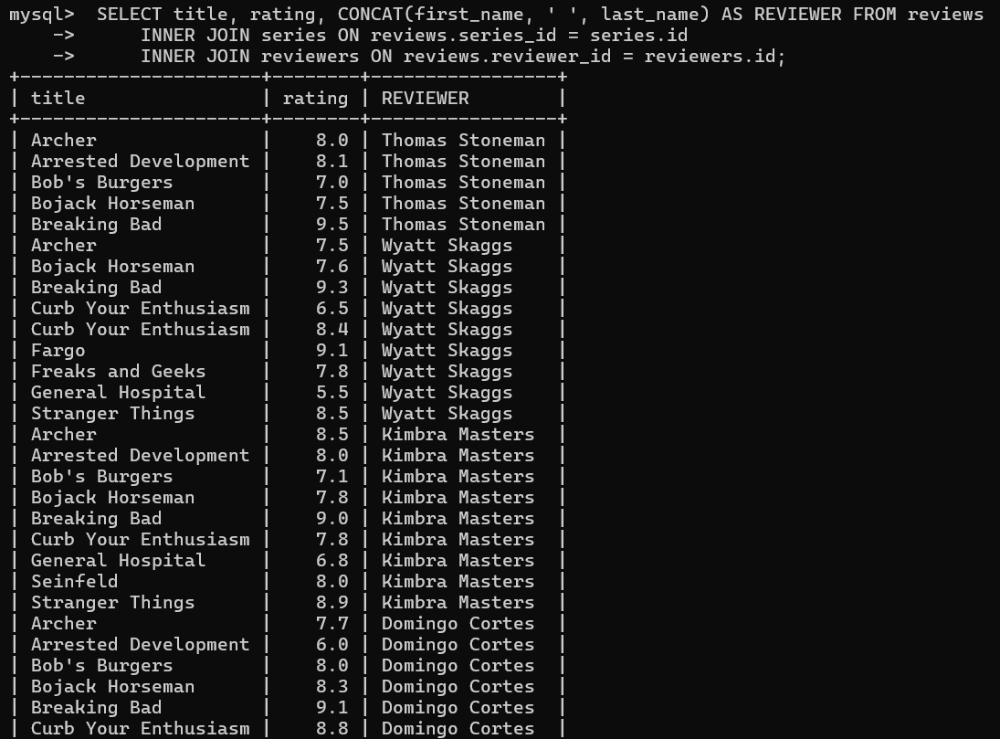

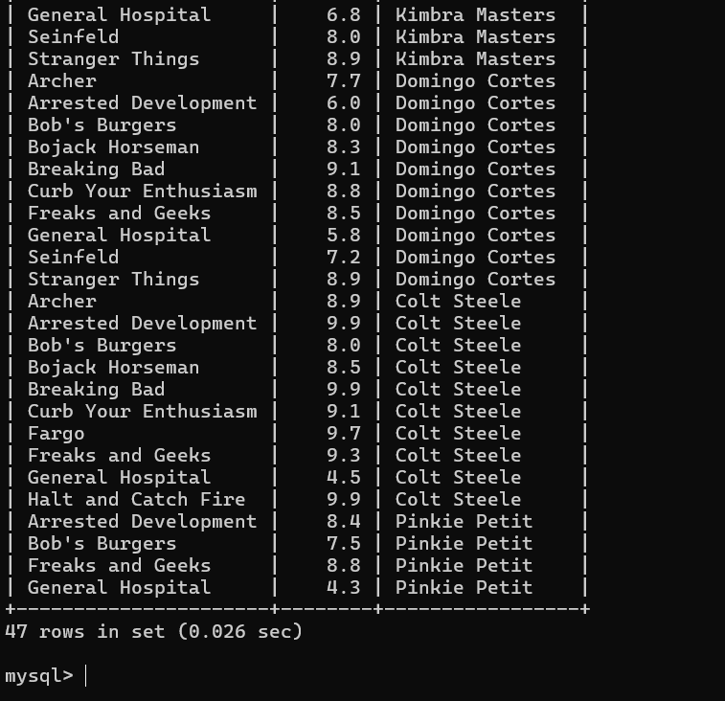

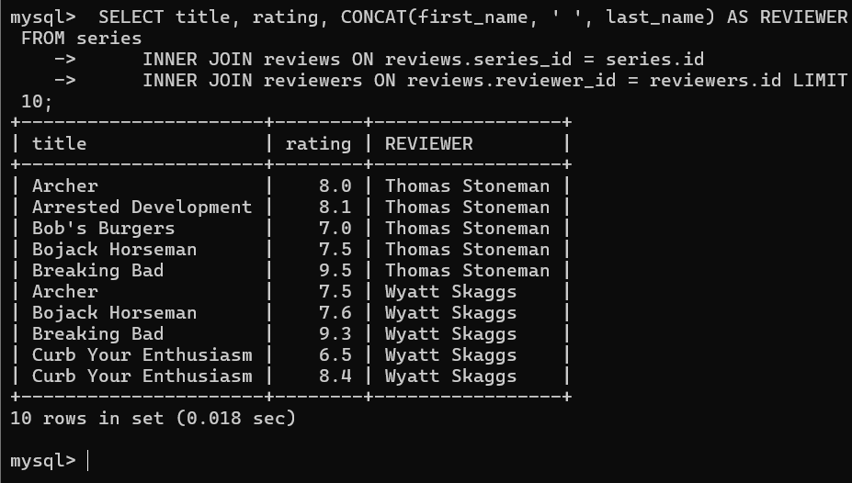
THIS SCREEN SHOT HAS THE ABOVE SIMILAR OUTCOME CODE IS CHANGED.

